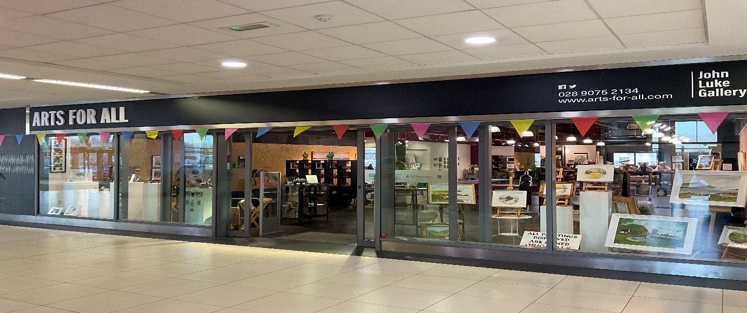

Arts for All
Annual Report
31st May 2023

Welcome
The date of our last AGM was 14th March 2022. Please find the Arts for All annual report for 2022-2023.

Introduction
This report aims to outline the innovative and inspiring work carried out by Arts for All along with opportunities and challenges for the organisation during the period.

Governing Document
Arts for All is registered with the Charity Commission for Northern Ireland under reference NIC 102821 and is governed by a constitution.

Board and Governance
Arts for All is governed by a dedicated voluntary board made up of eight individuals with a range of specialist backgrounds. The board is diverse, well connected to the creative, statutory, community development and charity sectors.
The board is fully committed to:
- Ensuring the fulfilment of the charity's objectives
- Ensuring compliance with the law including health and safety and disability legislation
- Approving policies and procedures and monitoring implementation
- Contributing to medium and long-term organisational plans
- Ensuring financial solvency
Ten meetings are held annually. Meetings are recorded with points of action noted.
Board papers are circulated to directors and to the Arts Council of Northern Ireland (ACNI).
In the spirit of accountability, observers are welcome to see how meetings are run.

Location
Arts for All is now based at Cityside Retail Park, Belfast BT15 1WA, and has one of the largest community art spaces and gallery in Belfast. The relocation was during 2019 has allowed the organisation to be more visible to those in the Belfast area as the shopping centre is a centre point for all communities in north Belfast.
During September 2020 Arts for All opened an additional unit and called it “The Pod” with over 7000 sq ft.

Staffing
During 2022 -2023
Jill McDermott continued in the role of Co Ordinator
Celia Felix started the role of Project Assistant funded By Future Foundations (July 2022).
Lauren Anthoney started the role of Facilitates Worker funded by Belfast Health & Social Care Trust (November 2022).
Programme and funders during 2022/2023
- Exhibitions at the John Luke Gallery. 20 Exhibitions during 2022/2023.
- Parents and tot’s creative drop in on Mondays (10-12).
- Art Yard – Creative art workshops for children on Saturdays
- Art in Business workshops (Jan 23) This course will support anyone entering the world of self-employment as an artist.
- First Aid Training & Mental Health First Aid Training.
- Activity hub (The Pod) for adults with learning disabilities (Mon-Fri).
- Continue to work in partnership with organisations & Schools across Belfast.
- The “I am inspired project” 22/23 working with over 40 adults with learning disabilities per week.

Principal Funding Sources
Funding this year came from several sources including The Arts Council of NI; Belfast City Council – Revenue and small grants; Department of Communities, Belfast Health & Social Care Trust, Halifax Foundation and The Ulster Scots Agency.

Thank you to our Supporters
We wish to thank the following funders for their continued support. Without these organisations it would be difficult to deliver so many programmes to the Community.
Arts Council of Northern Ireland – Lottery funding
Belfast City Council – Core multi annual funding
Department of Communities – Core programme
Belfast City Council – Community Building revenue programme Belfast Health & Social Care Trust – running & programming costs
Halifax Foundation – running costs
Ulster Scots Agency – running costs

Thank you
This concludes my report of the Arts for All activity for 2022-2023

Jill McDermott
Co Ordinator
TREASURERS REPORT

On behalf of Arts for All, I would like to take this opportunity to thank our funders for their continued support and financial assistance, without this we would be unable to deliver the current programmes designed to meet the needs of our community.
Grants received during 2022/2023 include
- Arts Council NI
- Department of Social Development
- Belfast City Council
- Belfast Health & Social Care Trust
- Halifax Foundation NI
- Ulster Scots Agency

Members of staff continue to apply for funding for programmes for our user groups and have secured further funding from Belfast Health and Social Care Trust to secure the Pod facility for another year. (2023)
I am also happy to report that the core funding has been secured for this financial year (2023) from Belfast City Council.
I also want to congratulate everyone involved with Arts for All and thank them for their time and effort in making this organisation the success that it is.

Muriel Bowyer
Treasurer
Arts for All

Signed – Date – 31/5/2023

